Review Scraper

End to end project from scratch till cloud deployment

**Preface**

This document describes a step by step guide for creating a web scraper. Particularly, it is related to a review scraper right from scratch and then deploying it to the heroku cloud platform. Text scrapers are extensively used in the industry today for competitive pricing, market studies, customer sentiment analysis etc. It takes a simple example of an online smart phone purchase and tries to explain everything simply, extensively, and thoroughly to create a review scraper.

**Web Scraping(Text)**

1. **Introduction:**

Web scraping is a technique using which the web pages from the internet are fetched and parsed to understand and extract specific information. Web scrapping consists of two parts:

* Web Crawling🡪 Accessing the web pages over the internet and pulling data from them.
* HTML Parsing🡪Parsing the HTML content of the web pages obtained through web crawling and then extracting specific information from it.

Let’s take an example:

how do we buy a phone online?

1. We first look for a phone with good reviews
2. We see on which website it’s available at the lowest price
3. We check whether it’s delivered in our area or not
4. If everything looks good, then we buy the phone.

What if there is a computer program that can do all of these for us? That’s what web scrapers necessarily do. They try to understand the webpage content as a human would do.

There are many other examples of the applications of web scraping.

In this document, we’ll take the example of buying a phone online further and try to scrap the reviews from the website about the phone that we are planning to buy.

If we open filpkart.com and search for ‘iPhone’, the search result will be as follows:

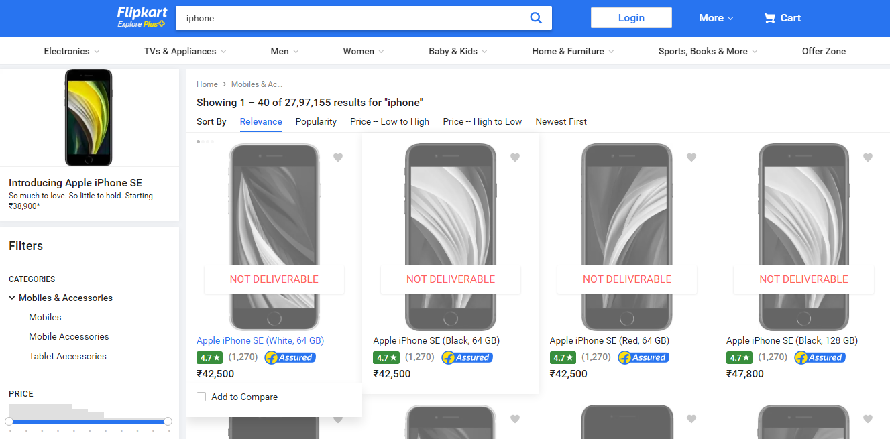(Currently, products are showing as not deliverable due to covid 19. Please ignore this)

Then if we click on a product link, it will take us to the following page:

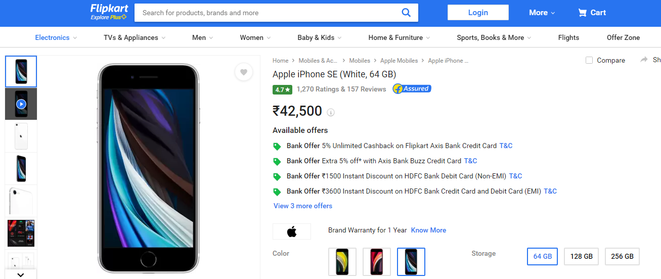

If we scroll down on this page, we’ll get to see the comments posted by the customers:

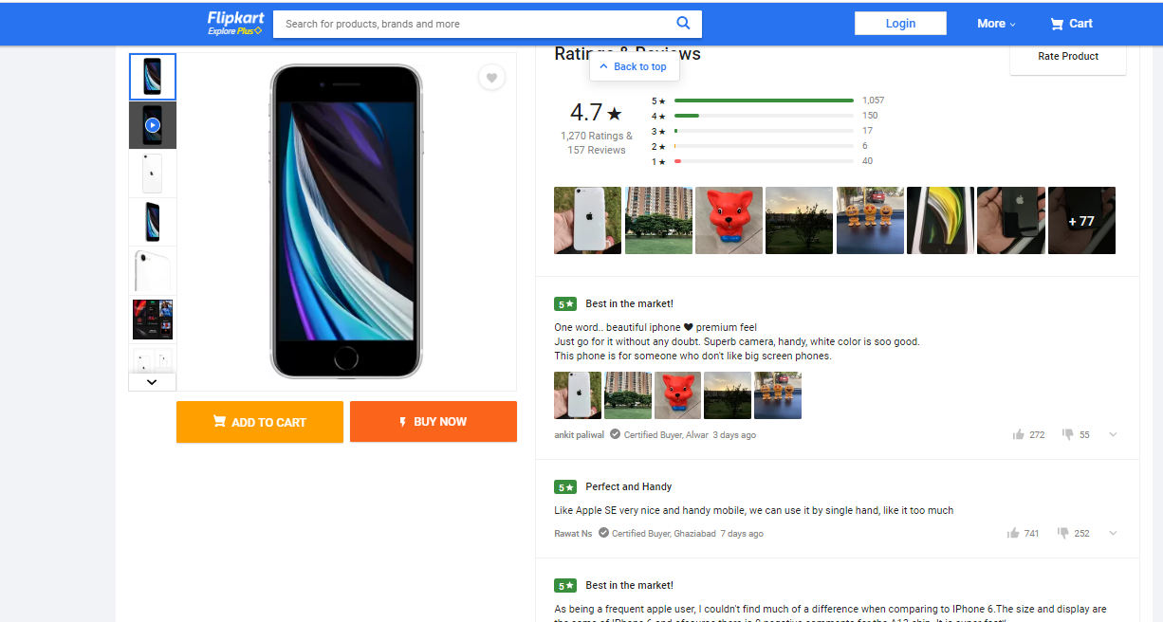

Our end goal is to build a web scraper that collects the reviews of a product from the internet.

1. **Prerequisites:**

The things needed before we start building a python based web scraper are:

* Python installed.
* A Python IDE(Integrated Development Environment): like PyCharm, Spyder, or any other IDE of choice. I have used PyCharm
* Flask Installed. (A simple command: pip install flask)
* Understanding of Python and HTML.
* Basic understanding of Git (download Git CLI from <https://gitforwindows.org/> )

**3. Application Architecture:**

The architecture of the application is:

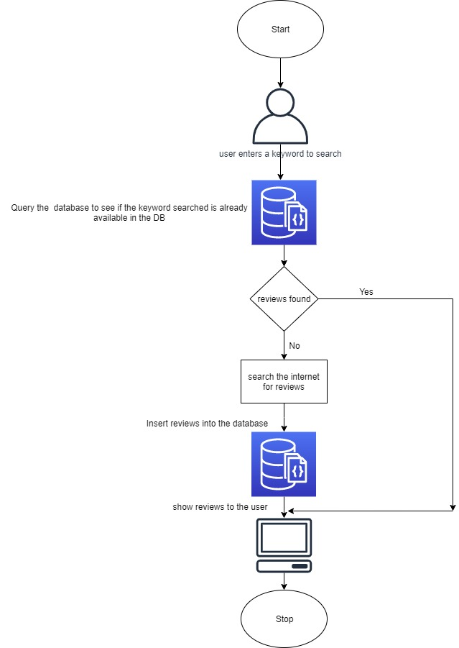

Note: Mongodb is removed currently and will be added in next version

**4. Python Implementation:**

**Note:** I have used PyCharm as an IDE.

1. Let’s create a folder called ‘reviewScrapper’ on our local machines.
2. Inside that folder, let’s create two more folders called ‘static’ and ‘templates’ to hold the code for the UI of our application. Inside ‘static’, let’s create a folder called ‘css’ for keeping the stylesheets for our UI.
3. Let’s create a file called ‘flask_app.py’ inside the ‘reviewScrapper’ folder.
4. Inside the folder ‘css’, create the files: ‘main.css’ and ‘style.css’.



1. Inside the folder ‘templates’, create three HTML files called: ‘base.html’,’index.html’, and ‘results.html’.



base.html🡪 It acts as the common building block for the other two HTML pages.

index.html🡪 Home page of our application.

results.html🡪 Page to show the reviews for the searched keyword.

1. Now, the folder structure should look like:

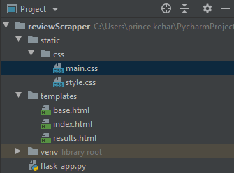

1. Now, let’s understand the flow:
2. When the application starts, the user sees the page called ‘index.html’.
3. The user enters the search keyword into the search box and presses the submit button.
4. The application now searches for reviews and shows the result on the ‘results.html’ page.
5. Understanding flask_app.py.



1. Import the necessary libraries:

fromflask import Flask, render_template, request,jsonify  
from flask_corsimport CORS,cross_origin  
import requests  
from bs4 import BeautifulSoupas bs  
from urllib.requestimport urlopenas uReq  
import pymongo

1. Initialize the flask app

app = Flask(__name__) # initialising the flask app with the name 'app'

1. Creating the routes to redirect the control inside the application itself. Based on the route path, the control gets transferred inside the application.

@app.route('/',methods=['POST','GET']) # route with allowed methods as POST and GET

1. Now let’s understand the ‘index()’ function.
2. If the HTTP request method is POST(which is defined in index.html at form submit action), then the application tries to fetch the details from the internet, as shown below:

flipkart_url = "https://www.flipkart.com/search?q=" + searchString# preparing the URL to search the product on Flipkart  
uClient = uReq(flipkart_url) # requesting the webpage from the internet  
flipkartPage = uClient.read() # reading the webpage  
uClient.close() # closing the connection to the web server  
flipkart_html = bs(flipkartPage, "html.parser") # parsing the webpage as HTML

1. Once we have the entire HTML page, we try to get the product URL and then jump to the product page. It is similar to redirecting to the following page:

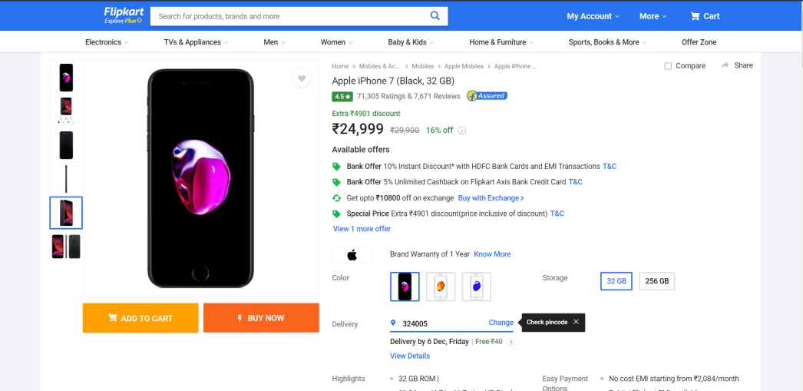

The equivalent Python code is:

productLink = "https://www.flipkart.com" + box.div.div.div.a['href'] # extracting the actual product link  
prodRes = requests.get(productLink) # getting the product page from server  
prod_html = bs(prodRes.text, "html.parser") # parsing the product page as HTML

1. On the product page, we need to find which HTML section contains the customer comments. Let’s do inspect element(ctrl+shift+i) on the page first to open the element-wise view of the HTML page. There we find the tag which corresponds to the customer comments as shown below:

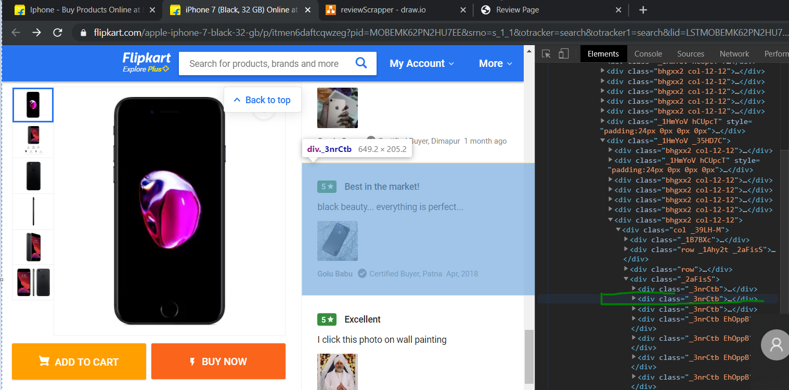

Python code for implementing the same is:

commentboxes = prod_html.find_all('div', {'class': "_3nrCtb"}) # finding the HTML section containing the customer comments

1. Once we have the list of all the comments, we now shall extract the customer name, the rating, comment heading, and the customer comment from the tag.

The Python code for the same is:

# iterating over the comment section to get the details of the customer and their comments  
for commentboxin commentboxes:  
try:  
 name = commentbox.div.div.find_all('p', {'class': '_3LYOAd _3sxSiS'})[0].text  
  
except:  
 name = 'No Name'  
  
try:  
 rating = commentbox.div.div.div.div.text  
  
except:  
 rating = 'No Rating'  
  
try:  
commentHead = commentbox.div.div.div.p.text  
except:  
commentHead = 'No Comment Heading'  
try:  
comtag = commentbox.div.div.find_all('div', {'class': ''})  
custComment = comtag[0].div.text  
except:  
custComment = 'No Customer Comment'

If you notice, the parsing is done using the try-except blocks. It is done to handle the exception cases. If there is an exception in parsing the tag, we’ll insert a default string in that place.

1. Once we have the details, we’ll return the ‘results.html’ page as the response to the user containing all the reviews. The python code for that is:

mydict = {"Product": searchString, "Name": name, "Rating": rating, "CommentHead": commentHead,  
"Comment": custComment} # saving that detail to a dictionary  
reviews.append(mydict) # appending the comments to the review list  
return render_template('results.html', reviews=reviews) # showing the review to the user

1. After this, we’ll just run our python app on our local system, and it’ll start scraping for reviews as shown below:

Home Page:

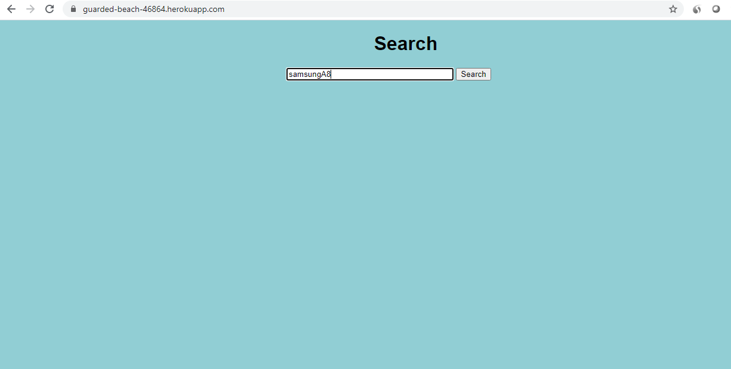

Search Results:

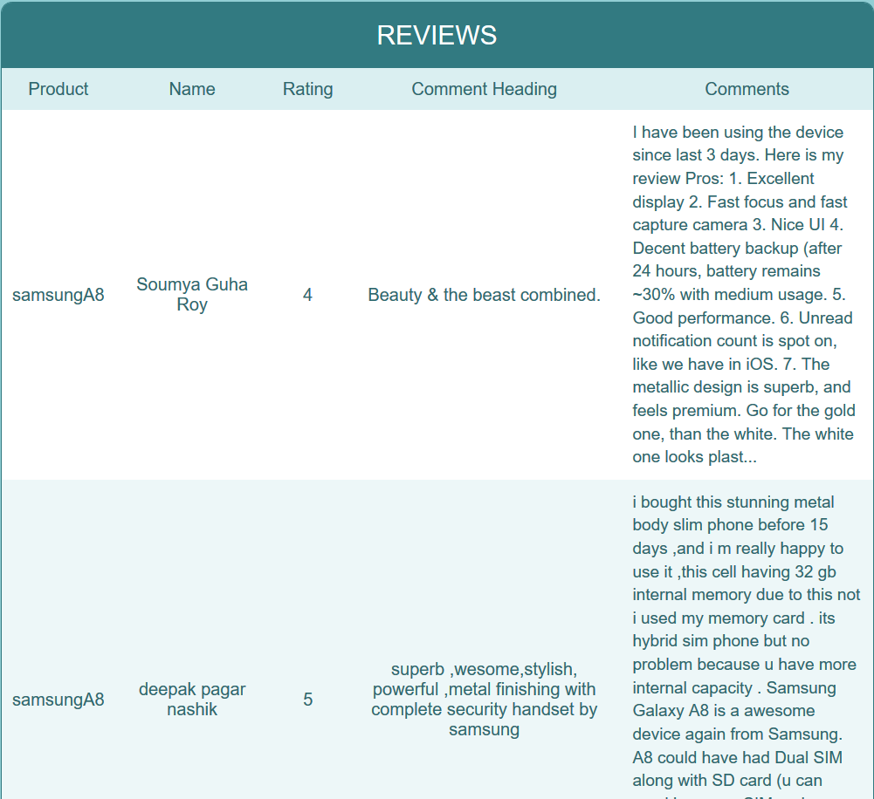

**5. Heroku:**

The Python app that we have developed is residing on our local machine. But to make it available to end-users, we need to deploy it to either an on-premise server or to a cloud service. Heroku is one such cloud service provider. It is free to use for some services upto a limit.

We’ll deploy this application to the Heroku cloud, and then anybody with the URL can then consume our app.

**6. Heroku Basics:**

* We’ll first go to heroku.com, and we’ll create a new account if we already don’t have one.
* We’ll download and install the Heroku CLI from the Heroku website: <https://devcenter.heroku.com/articles/heroku-cli>.

**7. Steps before cloud deployment:**

We need to change our code a bit so that it works unhindered on the cloud, as well.

1. Add a file called ‘gitignore’ inside the ‘reviewScrapper’ folder. This folder contains the list of the files which we don’t want to include in the git repository. My gitignore file looks like:

.idea

As I am using PyCharm as an IDE, and it’s provided by the Intellij Idea community, it automatically adds the .idea folder containing some metadata. We need not include them in our cloud app.

1. Add a file called ‘Procfile’ inside the ‘reviewScrapper’ folder. This folder contains the command to run the flask application once deployed on the server:

web: gunicornapp:app

Here, the keyword ‘web’ specifies that the application is a web application. And the part ‘app:app’ instructs the program to look for a flask application called ‘app’ inside the ‘app.py’ file. [Gunicorn](https://en.wikipedia.org/wiki/Gunicorn) is a Web Server Gateway Interface (WSGI) HTTP server for Python.

1. Open a command prompt window and navigate to your ‘reviewScrapper’ folder. Enter the command ‘pip freeze > requirements.txt’. This command generates the ‘requirements.txt’ file.

requirements.txt helps the Heroku cloud app to install all the dependencies before starting the webserver.

1. We have created a new file ‘app.py’ inside the review scrapper folder:



* + 1. Remove the first flask_app file from the directory. Resulting folder structure:

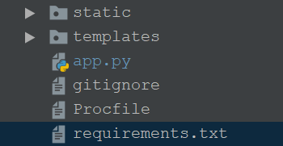

* + 1. A default route has been added to the app.py file to direct to the home page when the application is initially invoked as shown below:

@app.route('/',methods=['GET']) # route to display the home page  
@cross_origin()  
defhomePage():  
return render_template("index.html")

* + 1. We have removed the part where we were writing to MongoDB. Consuming MongoDB might incur charges. So, we have removed that part.

**8. Heroku app creation and deployment**

1. After installing the Heroku CLI, Open a command prompt window and navigate to your ‘reviewScrapper’ folder.
2. Type the command ‘heroku login’ to login to your heroku account:
3. After logging in to Heroku, enter the command ‘heroku create’ to create a heroku app. It will give you the URL of your Heroku app after successful creation.
4. Before deploying the code to the Heroku cloud, we need to commit the changes to the local git repository.
5. Type the command ‘git initto initialize a local git repository.
6. Enter the command ‘git status’ to see the uncommitted changes.
7. Enter the command ‘git add .’ to add the uncommitted changes to the local repository.
8. Enter the command ‘git commit -am "make it better"’ to commit the changes to the local repository.
9. Enter the command ‘git push heroku master’ to push the code to the heroku cloud.
10. After deployment, heroku gives you the URL to hit the web API.
11. Once your application is deployed successfully, enter the command ‘heroku logs --tail’ to see the logs.

**Final Result:** 

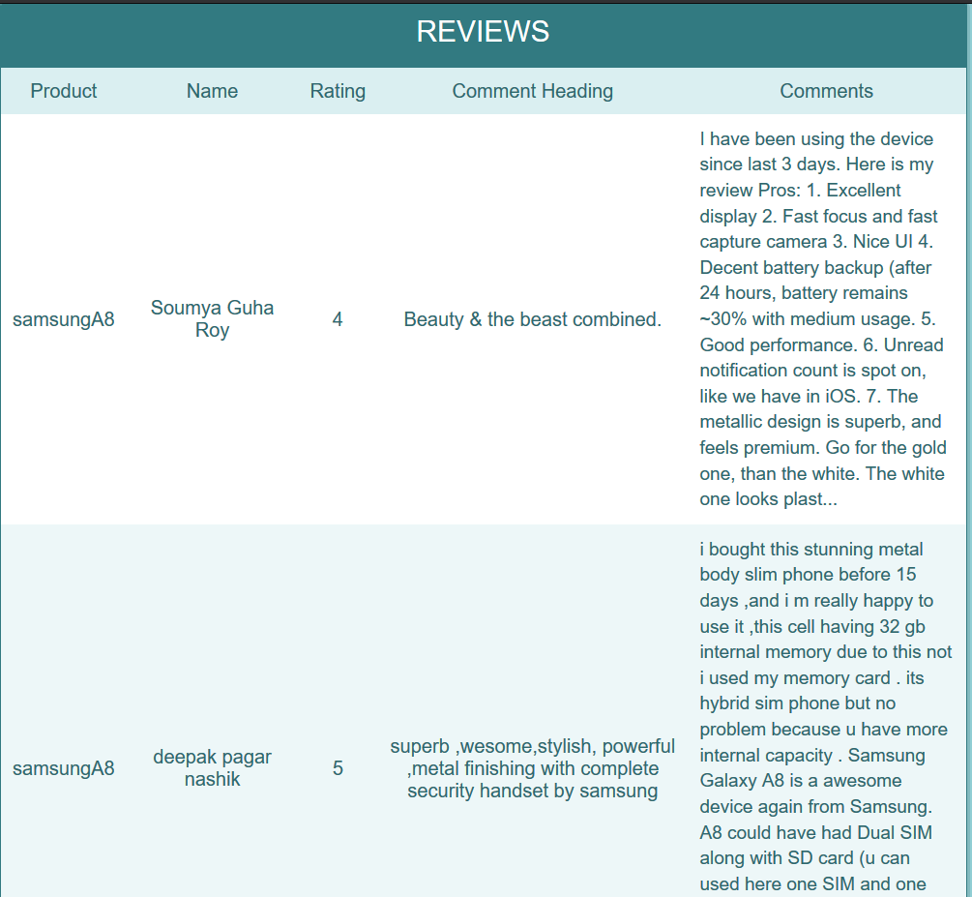

Thank You!